UCD Graduate Studies
Brightspace Enrolment
Graduate Orientation
graduatestudies@ucd.ie
8-1-2025


Contents
- How to enrol in Orientation for Graduate Research Students 25/26 Explore Module

- How to enrol in Orientation for Graduate Research Students 25/26 Explore Module

- Open Brightspace
- Click on the Explore link in the blue navigation bar
- Search for Orientation for Graduate Research Students 25/26 using the search box

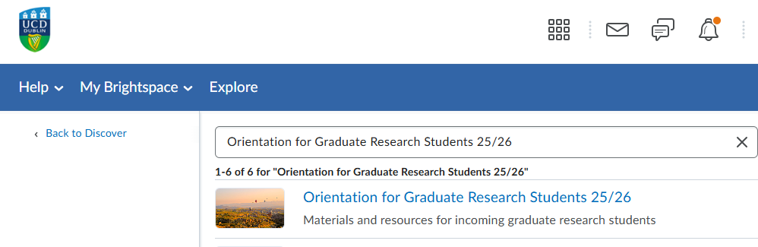

- Click on the module and click the ‘Enroll in Course’ button:

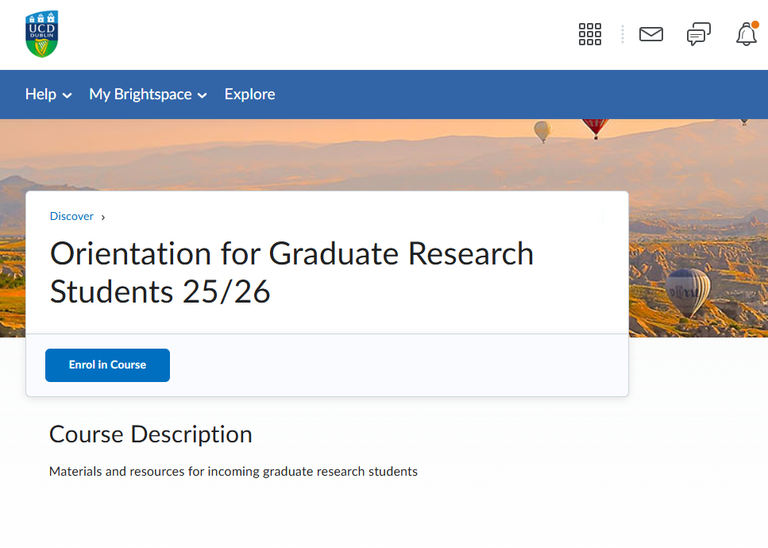
- Once you are enrolled, you can find the module in the My Modules widget on your Brightspace homepage.

